|  |  |
| --- | --- |
| logo_ec_17_colors_300dpi | EUROPEAN COMMISSION  DIRECTORATE-GENERAL FOR ENERGY  Directorate C - Renewables, Research and Innovation, Energy Efficiency  **C.3 - Energy efficiency** |

**Guidelines accompanying:  
  
Commission Delegated Regulation (EU) No 811/2013 of 18 February 2013 supplementing Directive 2010/30/EU with regard to energy labelling of space heaters, combination heaters, packages of space heater, temperature control and solar device and packages of combination heater, temperature control and solar device  
  
Commission Delegated Regulation (EU) No 812/2013 of 18 February 2013 supplementing Directive 2010/30/EU with regard to energy labelling of water heaters, hot water storage tanks and packages of water heater and solar device  
  
Commission Regulation (EU) No 813/2013 of 2 August 2013 implementing Directive 2009/125/EC with regard to ecodesign requirements for space heaters and combination heaters  
  
and  
  
Commission Regulation (EU) No 814/2013 of 2 August 2013 implementing Directive 2009/125/EC with regard to ecodesign requirements for water heaters and hot water storage tanks**

**(November 2014)**

**Table of Contents**

[1. Purpose of the guidelines and disclaimer 4](#_Toc402443607)

[1.1. The Regulations 4](#_Toc402443608)

[2. Scope 4](#_Toc402443609)

[2.1. Space Heaters and Combination Heaters 5](#_Toc402443610)

[2.2. Water Heaters 5](#_Toc402443611)

[3. Product environmental impacts 5](#_Toc402443612)

[4. State of play of legislation 6](#_Toc402443613)

[4.1. History of product legislation to date 6](#_Toc402443614)

[4.2. Timetable 6](#_Toc402443615)

[4.3. Review 7](#_Toc402443616)

[5. Key requirements 7](#_Toc402443617)

[5.1. Labelling requirements for single products 9](#_Toc402443618)

[5.2. Labelling requirements for packages 10](#_Toc402443619)

[5.3. Packages where not all information is available 20](#_Toc402443620)

[6. Frequently Asked Questions 21](#_Toc402443621)

# Purpose of the guidelines and disclaimer

The Ecodesign and Energy Labelling regulations for space heaters and water heaters were published in 2013. The regulations establish minimum requirements and an energy labelling scheme for the products in their scope. These guidelines aim to help relevant stakeholders, including industry and public authorities, to implement the Regulations in practice. They summarise the most relevant information from the regulations to give SMEs an introduction to the subject matter and answer the most common questions.

The guidelines are intended to be used only for facilitating the implementation of the Regulations. They are not intended to replace the Regulations or to provide “interpretation” beyond their intent. The guidelines only reflect the opinion of the Commission services and are not legally binding. A finally binding legal interpretation of EU legislation may only be provided by the European Court of Justice. The guidelines are without prejudice to the position the Commission might take should an issue arise in a procedure before the European Court of Justice.

## The Regulations

The Commission has published the following regulations concerning space and water heaters:

* Commission Delegated Regulation (EU) No 811/2013 of 18 February 2013 supplementing Directive 2010/30/EU with regard to energy labelling of space heaters, combination heaters, packages of space heater, temperature control and solar device and packages of combination heater, temperature control and solar device[[1]](#footnote-1);
* Commission Delegated Regulation (EU) No 812/2013 of 18 February 2013 supplementing Directive 2010/30/EU with regard to energy labelling of water heaters, hot water storage tanks and packages of water heater and solar device[[2]](#footnote-2);
* Commission Regulation (EU) No 813/2013 of 2 August 2013 implementing Directive 2009/125/EC with regard to ecodesign requirements for space heaters and combination heaters;
* Commission Regulation (EU) No 814/2013 of 2 August 2013 implementing Directive 2009/125/EC with regard to ecodesign requirements for water heaters and hot water storage tanks[[3]](#footnote-3);
* [Commission Delegated Regulation (EU) No 518/2014 of 5 March 2014 amending Commission Delegated Regulations (EU) No 1059/2010, (EU) No 1060/2010, (EU) No 1061/2010, (EU) No 1062/2010, (EU) No 626/2011, (EU) No 392/2012, (EU) No 874/2012, (EU) No 665/2013, (EU) No 811/2013 and (EU) No 812/2013 with regard to labelling of energy-related products on the internet](http://eur-lex.europa.eu/legal-content/EN/TXT/?uri=uriserv:OJ.L_.2014.147.01.0001.01.ENG)[[4]](#footnote-4).

# Scope

## Space Heaters and Combination Heaters

The scope of the Ecodesign and Energy Labelling Regulations on space and combination heaters is different. While the Ecodesign Regulation covers products with a rated output up to 400 kW, the Energy Labelling Regulation covers products with a rated output up to 70 kW.

In both cases, heaters designed for using gaseous or liquid fuels from biomass are excluded. Heaters using solid fuels are also excluded, these will be covered by separate Ecodesing and Energy Labelling measures.

The heaters covered by the Regulations can be classified as follows:

* Space heaters (other than heat pumps);
* Heat pump space heaters;
* Heat pump space heaters with fuel driven combustion unit;
* Combination heaters (other than heat pumps);
* Heat pump combination heaters;
* Heat pump combination heaters with fuel driven combustion unit.

## Water Heaters

Regarding Ecodesign and Energy Labelling of water heaters and hot water storage tanks, the scope also differs between the two Regulations. Ecodesing covers water heaters with a rated output equal or below 400 kW and storage tanks with a storage volume up to 2000 litres while the limit values are 70 kW and 500 litres for Energy Labelling respectively.

As for space heaters, products using gaseous or liquid fuels from biomass or solid fuels are excluded from the scope.

The products covered can be classified as follows:

* Water heaters (other than heat pumps);
* Storage Water Heaters (other than heat pumps);
* Heat pump Water heaters;
* Heat Pump Storage Water Heaters;
* Heat pump Water heaters with fuel driven combustion unit;
* Heat Pump Storage Water Heaters with fuel driven combustion unit;
* Hot Water Storage Tanks.

# Product environmental impacts

The preparatory study identified and analysed the relevant environmental impacts of heaters and water heaters. The use phase of the product has been clearly identified as the most important phase in terms of both environmental impacts and having the most potential for improvement. Therefore no specific requirements considering production, transport or end of life were proposed and the regulatory measures focus on the use phase and, for ecodesign also on the end-of-life phase.

As for most of the products subject to ecodesign regulation, the primary energy consumption during the use phase is the source of the primary impact via the (direct and indirect) carbon emissions.

Emissions from the combustion of fuel (e.g. NOx, SO2) are also relevant for all heaters and water heaters with a burner. Electric heaters do not directly produce emissions of this kind, so they are not regulated for them.

In addition to the air pollutants, noise is another relevant environmental impact for heat pumps.

There are other environmental impacts associated with these products, such as the use of refrigerants in heat pumps. These impacts can be subject to other existing legislation.

# State of play of legislation

## History of product legislation to date

From the start of the preparatory study, the first formal step in the ecodesign process, in 2006 until the publication of the implementing acts in late 2013, the ecodesign process for heaters and water heaters lasted eight years, mainly due to the complexity of the Regulations which cover products using different technologies and fuels.

## Timetable

* **26 September 2013.** Publication of the Regulations.
* **26 September 2015.** Tier 1 requirements regarding energy efficiency come into force for space and water heaters. Energy Labelling comes into force with a scale of A++ to G for space heaters and A to G for water heaters.
* **26 September 2016.** Specific review to analyse the possibility of setting different requirements for different types of water heaters.
* **26 September 2017.** Second tier requirements regarding energy efficiency come into force. The Energy Labelling scale for water heaters is updated to A+ to F.
* **26 September 2018**. Requirements regarding emissions of NOx come into force. Tier 3 requirements regarding the energy efficiency of water heaters start to apply. A review of the Regulations is to be presented.
* **26 September 2019**. The Energy Labelling scale for space heaters is updated to A+++ to D.

In addition, Article 8 of the Ecodesign regulation establishes that Member States may allow the placing on the market and/or putting into service of heaters and water heaters which comply with the national provisions in force when the Regulation was adopted regarding seasonal space heating energy efficiency, water heating energy efficiency and sound power level. The deadline for this provision is 26 September 2015.

Furthermore, placing on the market and/or putting into service of heaters and water heaters, which comply with the national provisions in force when this Regulation was adopted regarding emissions of nitrogen oxides may be allowed until 26 September 2018.

## Review

A review of the four Regulations is foreseen in 2018.

The review of the Ecodesign Regulations shall assess:

* The appropriateness of setting ecodesign requirements for greenhouse gas emissions related to refrigerants;
* The level of the ecodesign requirements for emissions of carbon monoxide, hydrocarbons and particulate matter that may be introduced;
* The appropriateness of setting ecodesign requirements for heaters specifically designed for using gaseous fuels or liquid fuels predominantly produced from biomass;
* The validity of the conversion coefficient value;
* The appropriateness of introducing third party certification.

In addition, before September 2016 the appropriateness of setting separate ecodesign requirements for different types of water heaters shall be evaluated.

Regarding Energy Labelling, the following aspects need to be evaluated:

* Any significant change in the market share of various types of heaters related to the labels;
* The feasibility and usefulness of indicating heater efficiency in the label;
* The appropriateness of the package fiches and labels;
* The appropriateness of including passive flue recovery devices in the scope of Regulation 811/2013.

# Key requirements

For space and combination heaters, the space heating energy efficiency is the key parameter. As heating demand is not constant over the year, the share of part load operation has to be reflected in the performance criterion.

The space heating energy efficiency class reflects these seasonal differences in one aggregated indicator. For fuel driven heaters, as well as for cogeneration heaters with supplementary heaters, the part-load behaviour has to be considered, whereas for electric boiler heaters as well as cogeneration heaters without supplementary heaters, only the efficiency at rated output is taken into account. The requirements for the space heating energy efficiency class are independent of the size or the power of the heater in question. The requirement is set as an efficiency criterion for all boiler sizes.

For combination heaters and water heaters, the water heating energy efficiency is the essential parameter for indicating the efficiency of the hot water generation. The requirements for the water heating energy efficiency class are set according to the heater’s output power. The heaters have been distinguished in classes from 3XS to 4XL with the efficiency requirements rising with the size of the heater.

In addition to the energy efficiency criteria, the regulation defines four additional compliance criteria aimed at reducing other relevant environmental impacts, including:

* The sound level, which is only relevant for heat pumps;
* Nitrogen oxide emissions for fuel based space and combination heaters, as well as heat pumps with supplementary fuel based heaters;
* Standing losses for hot water storage tanks.

For the sound level, the requirements are size dependant; the heaters are classified according to their power output. The limit values are given as absolute values of indoor and outdoor sound power levels in decibels (dB).

For nitrogen oxides, the regulation prescribes emission levels in relation to the fuel input power (mg NO2equ/kWh).

For the storage volume criterion, the regulation prescribes a minimum load of the storage compartment. This minimum storage is differentiated between the size categories used for water heating efficiency and is given in litres. This criterion is only relevant for boilers of size M and above.

The maximum standing losses are defined as a power (in Watts) expressed as a function of the storage capacity.

The following table gives an overview of the criteria to be fulfilled as well as the dates on which these criteria come into force.

|  |  |  |  |  |  |
| --- | --- | --- | --- | --- | --- |
|  | **Space Heating Energy Efficiency** | **Water Heating Energy Efficiency** | **Sound Power Level** | **Emissions of Nitrogen oxides** | **Standing Losses** |
| **TIER I** | 26.09.2015 | 26.09.2015 | 26.09.2015 | 26.09.2018 | 26.09.2017 |
| **TIER II** | 26.09.2017 | 26.09.2017 |  |  |  |
| **TIER III** |  | 26.09.2018 |  |  |  |
| **Space heaters (other than heat pumps)** |  |  |  |  |  |
| **Heat pump space heaters** |  |  |  |  |  |
| **Heat pump space heaters with fuel driven combustion unit** |  |  |  |  |  |
| **Combination heaters (other than heat pumps)** |  |  |  |  |  |
| **Heat pump combination heaters** |  |  |  |  |  |
| **Heat pump combination heaters with fuel driven combustion unit** |  |  |  |  |  |
| **Water heaters (other than heat pumps)** |  |  |  |  |  |
| **Storage Water Heaters (other than heat pumps)** |  |  |  |  |  |
| **Heat pump Water heaters** |  |  |  |  |  |
| **Heat Pump Storage Water Heaters** |  |  |  |  |  |
| **Heat pump Water heaters with fuel driven combustion unit** |  |  |  |  |  |
| **Heat Pump Storage Water Heaters with fuel driven combustion unit** |  |  |  |  |  |
| **Hot Water Storage Tanks** |  |  |  |  |  |

For most of the criteria the requirements have been differentiated according to the size of the product.

## Labelling requirements for single products

The labelling requirements address manufacturers as well as retailers to ensure the correct and consistent use of the label throughout the supply chain.

For space heaters, the energy efficiency labels coming into force in 2015 go from G to A++. In 2019, after the review of the Regulation, a new A+++ class will be added. In addition, the ecodesign requirements should lead to the lowest scoring products becoming obsolete.

In the case of water heaters, or combination heaters (for the water heating energy efficiency) the energy labelling scheme coming into force in 2015 goes from G to A, being modified to F to A+ in 2017.

From 26 September, 2015 manufacturers have to consider the following issues regarding labelling and information:

* For each space heater, a printed energy label in accordance with the regulation has to be provided. There are special provisions for several categories of space heaters defined in the regulation.
* A product fiche has to be provided.
* Technical documentation in accordance with the regulation has to be provided to the Commission on request.
* Product advertisements are required to reference the seasonal space heating energy efficiency class.
* Technical promotional material is also required to reference the seasonal heating energy efficiency class. Technical promotion material does not include price lists, when they only contain price information.

The obligations for retailers are:

* At the point of sale, each space heater on display shall be equipped with the respective printed energy label.
* Products marketed without the end user being able to see the label shall be accompanied with the relevant information laid down in the product fiche provided by the manufacturer.
* Advertisements are required to reference the seasonal space heating energy efficiency class.
* Technical promotional material is also required to reference the seasonal heating energy efficiency class.

The retailer must be provided with the label and the additional information by the distributor / manufacturer in such a way, that they are able to provide the necessary information to the customers. The technical parameters to be communicated are defined in Annex VII, paragraph 7 of the respective regulations.

## Labelling requirements for packages

For packages of space or combination heaters with temperature control and/or solar devices as well as for packages for water heaters and solar devices the dealer has to provide a customized label to ensure sufficient information for the end user.

The packages are defined in the Energy Labelling Regulations:

* In the case of Regulation 811/2013 they always contain a space heater or a combination heater, in addition to a temperature control and optionally a solar device.
* In the case of Regulation 812/2013 they always contain at least a water heater and a solar device.
* According to the relevant definitions in the Regulations, a solar device is made up of a solar collector, a solar hot water storage tank or a pump in the collector loop. A solar hot water storage tank is defined as a hot water storage tank storing heat energy produced by one or more solar collectors. This means that a solar device always contains a solar collector as a solar hot water storage tank is necessarily storing water coming from a collector and there cannot be a pump in the collector loop without a collector.

The dealer is defined in the Energy Labelling Directive as a retailer or other person who sells, hires, offers for hire-purchase or displays products to end users.

In the heating sector, the dealer is usually the person that is in the best position to advice end users on the different existing solutions for fulfilling their heating needs and their relative efficiency. In order to provide better information to consumers and recognising that not only the individual components of an installation are important but that the combination of them with temperature controls and/or solar devices can greatly increase their efficiency a “dealer” label has been introduced for space and water heaters.

The information provided by this “dealer label” is based on the information provided by the manufacturers for the individual components of the package which needs to be readily available for dealers in the technical documentation of the products.

The overall efficiency of the package has to be calculated in accordance with the Regulations. For the different combinations the regulation provides a calculation for the dealers to determine the efficiency class of the package. The following table gives an overview of the calculation methods depending on the preferential heater. The appropriate calculation method has to be chosen according to the type of package.

|  |  |  |
| --- | --- | --- |
| **Type of preferential heater** | **Space heating efficiency class calculation scheme** | **Water heating efficiency class calculation scheme** |
| Space heater or combination heater | Figure 1 (811/2013) | Figure 5 (811/2013) (for combination heaters) |
| Cogeneration space heater | Figure 2 (811/2013) |
| Heat Pump space heater | Figure 3 (811/2013) |
| Low-Temperature Heat Pump space heater | Figure 4 (811/2013) |
| Water heater | Not applicable | Figure 1 (812/2013) |

With the energy efficiency class resulting from the calculations, the package label can be designed appropriately.

### Calculation of space heating energy efficiency

#### Seasonal space heating energy efficiency

The value to be introduced is the seasonal space heating energy efficiency of the preferential heater, which can be a space heater, a combination heater, a cogeneration space heater, a heat pump space heater or a low-temperature heat pump space heater.

This information can be found on the product fiche that needs to provided by the supplier with the product.

Packages can also include a supplementary heater; in which case, the seasonal space heating energy efficiency of the supplementary heater is also needed. This value is to be found on the fiche of this supplementary heater.

#### Temperature control

Depending on the temperature control class, different correction factors are used, defined in classes. The class of the temperature control can be found on the fiche of the temperature control.

* Class I - On/off Room Thermostat: A room thermostat that controls the on/off operation of a heater. Performance parameters, including switching differential and room temperature control accuracy are determined by the thermostat's mechanical construction.
* Class II - Weather compensator control, for use with modulating heaters: A heater flow temperature control that varies the set point of the flow temperature of water leaving the heater dependent upon prevailing outside temperature and selected weather compensation curve. Control is achieved by modulating the output of the heater.
* Class III - Weather compensator control, for use with on/off output heaters: A heater flow temperature control that varies the set point of the flow temperature of water leaving the heater dependent upon prevailing outside temperature and selected weather compensation curve. Heater flow temperature is varied by controlling the on/off operation of the heater.
* Class IV - TPI room thermostat, for use with on/off output heaters: An electronic room thermostat that controls both thermostat cycle rate and in-cycle on/off ratio of the heater proportional to room temperature. TPI control strategy reduces mean water temperature, improves room temperature control accuracy and enhances system efficiency.
* Class V - Modulating room thermostat, for use with modulating heaters: An electronic room thermostat that varies the flow temperature of the water leaving the heater dependent upon measured room temperature deviation from room thermostat set point. Control is achieved by modulating the output of the heater.
* Class VI - Weather compensator and room sensor, for use with modulating heaters: A heater flow temperature control that varies the flow temperature of water leaving the heater dependent upon prevailing outside temperature and selected weather compensation curve. A room temperature sensor monitors room temperature and adjusts the compensation curve parallel displacement to improve room comfort. Control is achieved by modulating the output of the heater.
* Class VII - Weather compensator and room sensor, for use with on/off output heaters: A heater flow temperature control that varies the flow temperature of water leaving the heater dependent upon prevailing outside temperature and selected weather compensation curve. A room temperature sensor monitors room temperature and adjusts the compensation curve parallel displacement to improve room comfort. Heater flow temperature is varied by controlling the on/off operation of the heater.
* Class VIII – Multi-sensor room temperature control, for use with modulating heaters: An electronic control, equipped with 3 or more room sensors that varies the flow temperature of the water leaving the heater dependent upon the aggregated measured room temperature deviation from room sensor set points. Control is achieved by modulating the output of the heater.

The correction factor per class is:

|  |  |  |  |  |  |  |  |
| --- | --- | --- | --- | --- | --- | --- | --- |
| Class I | Class II | Class III | Class IV | Class V | Class VI | Class VII | Class VIII |
| 1% | 2% | 1.5% | 2% | 3% | 4% | 3.5% | 5% |

#### Weighting of the heat output of preferential and supplementary heaters (II)

This weighting factor depends on the results of the expression:

$$\frac{P_{sup}}{P_{rated}+P_{sup}}$$

*Psup* means the declared heat output of the supplementary heater while Prated refers to the preferential heater.

Depending on the result of the above expression and on the presence of a storage tank, “II” is provided in the Regulations

For preferential boiler space heaters or boiler combination heaters the following table shall be used:

|  |  |  |
| --- | --- | --- |
| Psup / (Prated + Psup) | With storage tank | Without storage tank |
| 0 | 0 | 0 |
| 0,1 | 0,30 | 0,37 |
| 0,2 | 0,55 | 0,7 |
| 0,3 | 0,75 | 0,85 |
| 0,4 | 0,85 | 0,94 |
| 0,5 | 0,95 | 0,98 |
| 0,6 | 0,98 | 1,00 |
| >0,7 | 1,00 | 1,00 |

For preferential cogeneration space heaters, heat pump space heaters, heat pump combination heaters or low-temperature heat-pumps the following table shall be used:

|  |  |  |
| --- | --- | --- |
| Prated / (Prated + Psup) | With storage tank | Without storage tank |
| 0 | 1,00 | 1,00 |
| 0,1 | 0,70 | 0,63 |
| 0,2 | 0,45 | 0,30 |
| 0,3 | 0,25 | 0,15 |
| 0,4 | 0,15 | 0,06 |
| 0,5 | 0,05 | 0,02 |
| 0,6 | 0,02 | 0 |
| >0,7 | 0 | 0 |

#### Solar contribution factors (III and IV)

Elements III and IV are calculated as follows:

$$III=\frac{294}{11·P_{rated}}$$

$$IV=\frac{115}{11·P_{rated}}$$

These values are combined with the collector size in m2, the tank volume in m3 and the collector efficiency in %. All these values are to be found in the solar device fiche.

A factor depending on the efficiency of the tank is also to be used:

|  |  |
| --- | --- |
| A+ | 0.95 |
| A | 0.91 |
| B | 0.86 |
| C | 0.83 |
| D-G | 0.81 |

#### Factors for heat pumps (V and VI)

For heat pumps the following values need also to be included:

* V. Difference between the seasonal space heating energy efficiencies under average and colder climate conditions, expressed in %.
* VI. Difference between the seasonal space heating energy efficiency under warmer and average climate conditions, expressed in %.

#### Space heating energy efficiency of the package

The space heating energy efficiency of the package is calculated according to the following table:

|  |  |
| --- | --- |
| A+++ | ≥ 150% |
| A++ | ≥ 125% |
| A+ | ≥ 98% |
| A | ≥ 90% |
| B | ≥ 82% |
| C | ≥ 75% |
| D | ≥ 36% |
| E | ≥ 34% |
| F | ≥ 30% |
| G | < 30% |

### Calculation of water heating energy efficiency for packages

#### Seasonal water heating energy efficiency (I)

The value to be introduced is the seasonal space heating energy efficiency of the preferential heater, which can be a space heater, a combination heater, a cogeneration space heater, a heat pump space heater or a low-temperature heat pump space heater.

This information can be found on the product fiche that needs to provided by the supplier of the product.

#### Solar contribution factors (II and III)

Elements II and III are calculated as follows:

$$II=\frac{220·Q_{ref}}{Q_{nonsol}}$$

$$III=\frac{Q_{aux}·2.5}{220·Q_{ref}}$$

Qref depends on the declared load profile.

|  |  |  |  |  |
| --- | --- | --- | --- | --- |
|  | M | L | XL | XXL |
| Qref | 5,845 | 11,655 | 19,07 | 24,53 |

Qnonsol and Qaux are to be found on the product fiche of the solar device.

*Figure 1 (811/2013): Calculation scheme for preferential boiler heaters (space heating energy 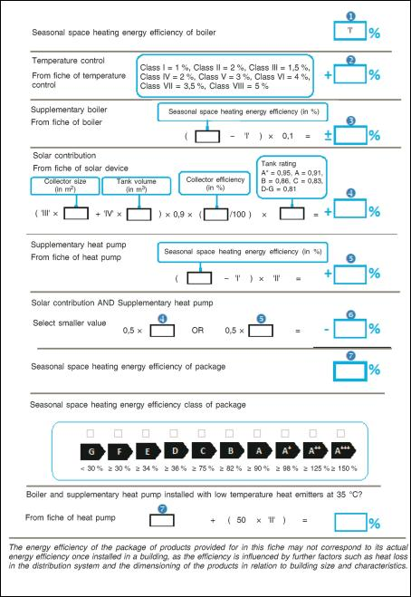efficiency)Figure 2 (811/2013): Calculation scheme for preferential cogeneration space heaters (space heating* 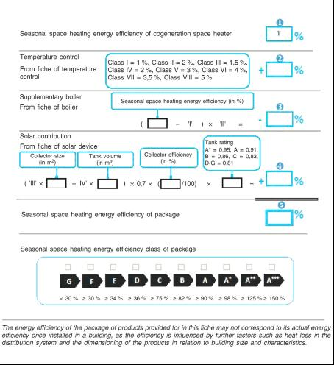*energy efficiency)*

*Figure 3 (811/2013): Calculation scheme for preferential heat pump heaters (space heating energy efficiency)*

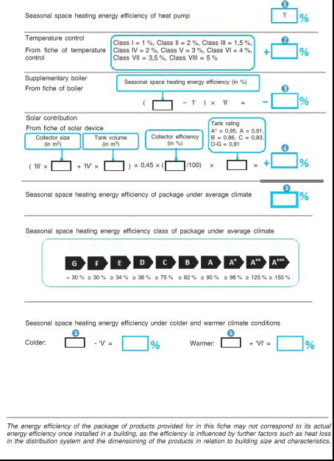

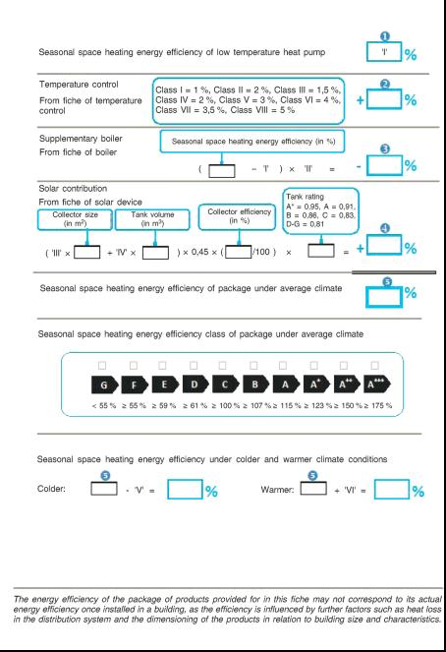*Figure 4 (811/2013): Calculation scheme for preferential low-temperature heat pump heaters (space heating energy efficiency)*

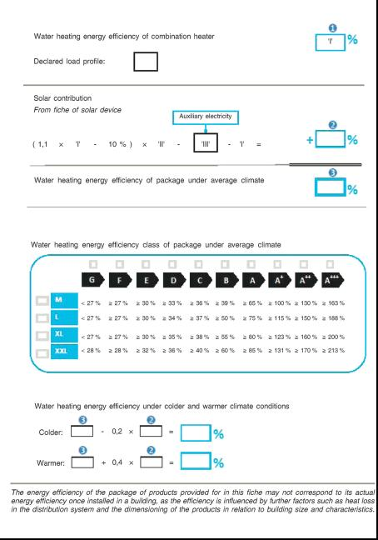*Figure 5 (811/2013): Calculation scheme for preferential boiler combination heaters (water heating energy efficiency)*

## Packages where not all information is available

In the case of packages providing domestic hot water using a space heater the water heating energy efficiency might not be available, or might only be available for a combination of the space heater with a specific hot water storage tank.

In this case, the dealer would not be able to provide the package label unless certain assumptions are made to estimate ηwh of a standard boilers used in solar packages.

The following calculation method is proposed.

$$η_{wh_calc}=\frac{Q_{ref}}{Q_{fuel}+CC·Q_{elec}+Q_{cor}}$$

$$Q_{fuel}=\left(Q_{ref}+\left(24-\frac{Q_{ref}}{P_{4}}\right)·P_{stby}\right)·\left(\frac{100}{η_{4}}\right)$$

$$Q_{elec}=Q_{elec,on}+Q_{elec,stby}=\left(24-ton\right)·PSB+ton·{el}_{max}$$

$$t_{on}=\left(Q_{ref}+\left(24-\frac{Q_{ref}}{P_{4}}\right)·P_{stby}\right)·\frac{1}{P_{4}}$$

All the necessary data can be found in the relevant Annexes of the Regulations or in the data sheet of the boiler.

This method makes a series of simplifications:

* The smart control factor is not used as it does not apply in this context;
* The tank losses are set to 0 as they are already considered in the SOLCAL method.

This method is only applicable to packages with a load profile M, L, XL and XXL.

Several tests have been carried out in order to verify the applicability of the proposed method, the results of which are shown below.



In order not to create an incentive driving the market towards calculation instead of measurements and to ensure that adequate information is provided to consumers the water heating energy efficiency to be used for the purposes of the package label when the calculation method is being used shall be:

$$η_{wh}=η_{wh_calc}·0.95$$

The graphic presented above is based on a series of 30 tests carried out according to EN 13203-2:2006 and the calculation method presented above.

If a normal error distribution is presumed, the correction applied to calculated results makes them more conservative than measured ones in around 90% of the cases.

# Frequently Asked Questions

***Is voluntary application of the label before the official introduction admitted? How to ensure uniform application in the EU?***

Voluntary application of the label before the official implementation date is not allowed under the Energy Labelling Directive which establishes that the supply and subsequent display of a label before the date specified in a delegated act for suppliers to supply the specific label concerned falls under "unauthorized use" of the label, which is defined in Article 2(k) of the Directive as the use of the label, other than by Member State authorities or EU institutions, in a manner not provided for in the Directive or in the a delegated act. Delegated acts specify the date from which a particular label shall be supplied. If it is supplied and subsequently displayed before that date the label is thus used in a manner not provided for in the delegated act.

Label classes (e.g. A+++), that are subject to further regulatory measures, must not be used before the date of coming into force of that specific label.

It is to be recognised that manufacturers need time to prepare for the coming into force of the requirements. In this respect, the Commission services would not recommend market surveillance authorities to take actions against a manufacturer providing the label through its distribution chain a reasonable amount of time before the date of application of the requirements (i.e. 26 September 2015).

***Can the energy label be displayed before application at trade fairs, where products are not sold and end-users do not have access (the fairs are only for professional intermediates, such as installers)?***

The energy labelling Regulations establish that the dealer has to ensure that each space or water heater bears the label at the point of sale. During a trade fair, placing on the market is not taking place, there is no obligation to display the label and at the same time information can be provided to professionals about the energy labelling class of the product.

***Should the energy label be delivered together with the heater (space heater, combination heater, water heater), inside the box, or could it be “provided for each space heater” by means of separate literature regarding the product, websites, brochures, evidence at sales point, etc.?***

It is required that the dealer is provided with correct and clear information on the energy performance of heaters. The means by which this information is obtained does not matter. The label may be delivered together with supplementary material and does not have to be delivered with each product as long as a sufficient number of labels are provided.

***With regard to the obligation to communicate the efficiency class, the definitions of energy related information and technical parameters are unclear (e.g. are dimensions technical parameters?).***

Dealers are obliged to provide information on the energy efficiency of the product together with any technical promotional material or together with information describing the technical parameters of the product. The technical parameters are reflected in Annex V of the Regulations. Dimensions are not listed as technical parameters.

***Is a price list of the supplier which is used for dealers only defined as technical promotional material?***

Any advertisement relating to a specific product and containing price information has to include a reference to the efficiency of the product. As price lists obviously include information on prices, they are covered by this obligation.

***For combination boilers with components delivered separately, should the manufacturer use one or two labels when bringing the package to the market? What if components are then sold separately by anybody in the distribution chain?***

If the boiler and the domestic hot water tank are sold under two different model identifiers, then the domestic hot water tank is considered as a hot water storage tank and the two components shall be labelled separately.

***In the heat pump and solar system labels, there are "European temperature maps" and "European solar maps" displaying three zones. Where can we find a precise definition of these zones?***

These zones were defined during the development of Regulation 206/2012 on air conditioners and are based on the climatic conditions of Strasbourg, Helsinki and Athens. Nevertheless, these zones are only indicative. Templates for the labels are available on the DG ENER Website.

<http://ec.europa.eu/energy/efficiency/labelling/labelling_en.htm>

***The product fiches describe in Regulations (EU) 811/2013 and 812/2013 are slightly different. How could we have a harmonisation to make the document management easier?***

The format of the fiches provided in the Regulations is only indicative. The key requirement is that the information requested is made available by the supplier. Therefore, the supplier can always construct a single fiche covering all the necessary information.

***How to deal with the labelling and ErP requirements of hybrid products made by the combination of two or more technologies in one casing, delivered on the market by one supplier? How to deal with heat pump integrating a fossil fuel supplementary heater?***

A “hybrid” put on the market consisting of two or more technologies integrated in one casing would be considered a “product”. The definition of the type of product is up to the supplier. If the leading technology is the heat pump, the hybrid will be labelled as a heat pump. If the leading appliance is the fossil fuel heater, the hybrid should be labelled as a fossil fuel heater.

In the absence of a calculation methodology for heat pumps integrating a fossil fuel supplementary heater, suppliers can use the same methodology proposed by EN 14825 for electrical supplementary heaters by replacing performances of electrical supplementary heater with the performances of fossil fuel supplementary heater. It is up to the standardisation process to develop specific standards for these hybrid products.

Systems made of a heat pump and a fossil fuel burner can be considered as:

* A heat pump heater equipped with a supplementary heater. In this case the heat pump shall fulfil the applicable requirements.
* A package of a heat pump and a boiler (or a package of a boiler and a heat pump).

***How can the manufacturer of free standing boilers ("boilers" put on the market without burner) verify and declare the compliance of the boiler to the ecodesign and labelling requirements?***

“Free standing boilers” are not equipped with a burner (heat generator). According to the definition of “space heater” in the Regulations they are excluded from the scope.

***What is the definition of preferential heater?***

A preferential heater is a heater that generates heat in cases where the heat demand is lower than or equal to its rated output.

In general, a preferential heater is a heater which is to be switched on first (usually because it gives the best efficiency). Only if the heat demand exceeds the output of the preferential heater, the supplementary heater is switched on.

***Can it be indicated that electronic instantaneous water heaters are more efficient than hydraulic instantaneous water heaters?***

The calculation of the water heating energy efficiency of water heaters is based on the tapping profiles provided in the Regulations. These tapping profiles are based on the energy content of the withdrawn water.

In the case of electric instantaneous water heaters (EEIWH) different technologies exist, hydraulically and electronically controlled products. Electronic electric instantaneous water heaters, through an electronic control system are better able to fine-tune the electrical power consumption to heat up the water to the requested water temperature, without the need of mixing cold water. This results in a reduction of the energy consumption when comparing EEIWHs to simple hydraulic electric instantaneous water heaters (HEIWH) for a real daily usage.

Manufacturers of EEIWHs might indicate in the product fiche (Annex IV of regulation 2013/812/EU) that the product saves energy when compared with hydraulic electric instantaneous water heaters (HEIWH).

***How can cogeneration space heaters that also provide domestic hot water be labelled?***

Cogeneration space heaters are defined as space heaters that simultaneously generate heat and electricity in a single process. In principle, they can also be designed to also provide heat to deliver hot drinking or sanitary water at given temperature levels, quantities and flow rates during given intervals and be connected to an external supply of drinking or sanitary water.

In such cases, information about their water heating energy efficiency can also be provided in the energy label, by using one of the following two options:

* Use the labels foreseen in Regulation 811/2013 for cogeneration space heaters and for combination heaters.
* Use the label foreseen in Regulation 811/2013 for combination heaters including the pictogram corresponding to the electricity function.

It is to be noted that the seasonal space heating energy efficiency of combination heaters needs to be determined according to point 3 of Annex VII of Regulation 811/2013. In the case of their water heating energy efficiency, point 5 needs to be applied, which mean that their electrical efficiency is only taken into account for the determination of their seasonal space heating energy efficiency.

***Have solar hot water storage tanks (solar devices designed to be connected to solar collectors) to comply with ErP requirements and to be labelled as hot water storage tanks?***

A solar hot water storage tank is a subcategory of a hot water storage tank and has in consequence to meet the relevant requirements under the Regulations.

***How could be defined a product made by a solar hot water storage tank specifically designed and connected with a solar collector, an electrical resistance and a bracket, put on the market as one single unit?***

If the electrical resistance operates as a backup immersion heater (thus, it generates heat only when the solar heat source is not sufficient to satisfy the required comfort levels), then the product is a solar only system.

If the electrical resistance is not a backup immersion heater, this product must be considered as a solar water heater.

***How is it defined a product made by a solar hot water storage tank with a pump and a controller placed on the market as one single unit? How shall it be labelled?***

It is a solar hot water storage tank, with a pump and a controller as defined by Regulation 812/2013 Annex I, point 39. It cannot be considered as solar only system because solar collectors are missing.

***How to label a water heater with a rated heat output < 70 kW, declared ErP compliant according to load profile 4XL (Reg. 814/2013). Is it correct to label this appliance using load profile 2XL (the highest one given by the Labelling regulation 812/2013)?***

The water heater is in the scope of the energy labelling Regulation and in consequence needs to be labelled. The load profile to be used is one of the load profiles provided in such Regulation.

***For heat pump water heaters which use ventilation exhaust air or indoor air or brine or water as the heat source, how to fill in the data for the colder and warmer conditions (these conditions do not apply to these kinds of products)?***

In the case of heat pumps using indoor air, exhaust air, brine or water as a heat source, there is no possible differentiation according to climate conditions, in this case, the values to be used for the three climates can be the same.

***Does the maximum tapping profile be used to test water heaters < 400kW having a rated capacity exceeding tapping profile 4XL?***

The water heater is in the scope of Regulation 814/2013 and in consequence needs to meet the minimum requirements set. The water heater is to be tested with the highest declared tapping profile (e.g. 4XL).

1. OJ L 239, 6.9.2013, p. 1. [↑](#footnote-ref-1)
2. OJ L 239, 6.9.2013, p. 83, [↑](#footnote-ref-2)
3. OJ L 239, 6.9.2013, p. 136. [↑](#footnote-ref-3)
4. OJ L 239, 6.9.2013, p. 162. [↑](#footnote-ref-4)