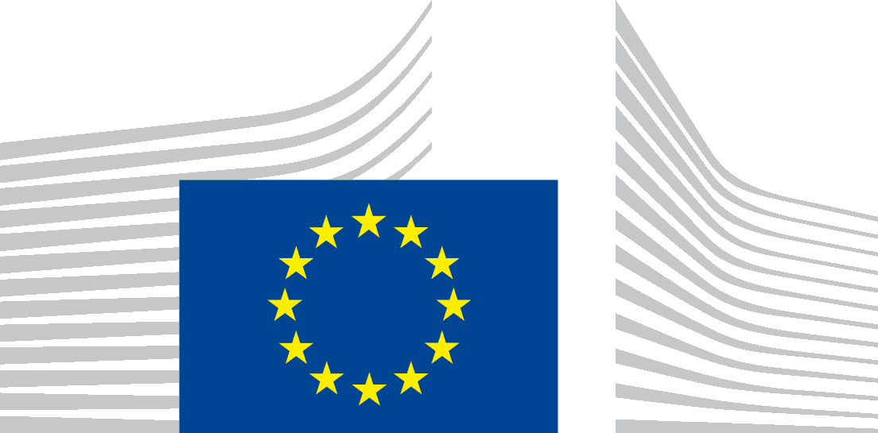 | EUROPEAN COMMISSION  DIRECTORATE-GENERAL FOR ENERGY  Directorate C - Renewables, Research and Innovation, Energy Efficiency  C.3 - Energy Efficiency
Brussels,
ENER/C3/PH (2014)

Draft Minutes
Meeting of the Consultation Forum under Article 18 of Directive 2009/125/EC on energy-related products
Electric motors

(Lot 30)

Brussels, 29 September 2014 (10.00 – 16:00)
Participants: See “Attendance List” in Annexes
EC Participants: Robert NUIJ (Chairman), Marcos GONZALEZ ALVAREZ (ENER)

Welcome and Presentation
The Chair welcomed the participants and indicated that the purpose of the meeting was to discuss the proposed draft Ecodesign Regulation on electric motors. The agenda was adopted without changes.

Working documents on electric motors
After a presentation by the Commission services the documents were discussed by Member States and stakeholders.
DE and DK asked for discussing the draft Regulation following the proposed legislative text. As no opposition was expressed the Commission services agreed to the proposal.

Article 1. Subject matter and scope
DE asked why small motors were included and asked for justification from a life cycle cost point of view for such inclusion.

DE requested a better definition and differentiation between “explosion proof motors” and “increased safety motors”. This comment was supported by BE and NL. BADEN-WÜRTTEMBERG, that participated in the meeting on a one off basis to provide input as a market surveillance authority, also asked for better definitions of “hand-held equipment” and “cordless or battery operation”.

DE indicated that not only motors in hand-held equipment but also motors used in appliances moved by hand should be excluded from the scope. This comment was supported by BE and VDMA.

EURELECTRIC indicated that the proposed Regulation will have a major impact on motors used in hydro, wind and nuclear plants that need to be certified for use in such environments, and that the application of the Regulation to these motors would have disproportionate costs. FORATOM added that in many cases it would be impossible to use the new motors due to space occupancy problems and earthquake resistance requirements.

EPEE mentioned that motors integrated into other products should be excluded from the scope as this would lead to double regulation without increasing the energy efficiency of the final product. This comment was supported by CECED, which added that the different timings for the coming into force of the requirements would have negative effects on the redesign cycle of the product. IT also agreed with excluding motors integrated into other products from the scope.

NL indicated that they support the inclusion of motors integrated into other products in the scope of the Regulation, BE, DK and ECOS also supported this inclusion.

ECOS indicated that small motors are included in the IEC standard and that only motors rated on continuous duty are covered.

BE asked the Commission to evaluate if a special provision is needed for replacement motors used as spare parts.

NL, DE, IT, BADEN-WÜRTTEMBERG, EPEE and CECED asked the Commission services to clarify who is responsible for compliance in the case of motors integrated into other products.

The Commission services indicated that a binding interpretation of the European legislation can only be provided by the European Court of Justice. The Commission services interpretation, as discussed with legal experts and other relevant Commission services, is based on the Ecodesign Directive and the “Blue Guide on the implementation of EU product rules”. The Commission services indicated that according to the “Blue Guide” the manufacturer of the final product is responsible for compliance with any relevant Regulation.

Article 2. Definitions
DK asked the Commission to remove the reference to 3-phases in the definition of variable speed drive. CEMEP considered that the definition of variable speed drive should be taken from the relevant European standard.

NL indicated that certain definitions were missing from the text and that they should be added to Article 2. This comment was supported by UK.

DE pointed out that the definitions should be revisited as there are special shape motors that, based on the current definitions, would be in the scope of the Regulation, although they should be excluded.

CEMEP said that 8-pole motors should not be covered by the Regulation, as they represent less than 1% of the market. They added that the energy efficiency requirement for brake motors should be IE2 as they usually work on intermittent duty and have increased rotor inertia. ECOS disagreed with CEMEP and indicated that 8-pole motors should be covered. DE considered that 8-pole motors are seldom used in Europe.

NL indicated that according to the current draft, medium voltage motors will only be addressed in a review in 2018. China already has minimum requirements for these motors. NL asked the Commission to speed up the process of developing requirements for medium voltage motors in order to avoid low efficiency medium voltage motors being brought to the European market. SE indicated that the test methods for medium voltage motors are already available and only a definition of efficiency levels is missing. Hence, the discussion on their inclusion should not be postponed until 2018. FI strongly supported the inclusion of medium voltage motors in the scope of the Regulation, indicating that minimum values could be set now and reassessed before they come into application. ECOS also indicated that more ambition was needed regarding medium voltage motors.

The Commission services concluded that, based on these views, the inclusion of medium voltage motors before 2018 would be analysed.

Article 3. Ecodesign requirements
DE asked the Commission services to further evaluate how to articulate the transitional period when the proposed Regulation comes into force repealing Regulation 640/2009, to avoid creating additional burdens for manufacturers that would need to create new documentation for the motors.

DK indicated that the number of tiers should be reduced and added that the current tier coming into force in 2017 under Regulation 640/2009 could be skipped. NL said that from a legal certainty point of view it would be better to make any change to the current Regulation from 2018 onwards. SE said that they are in favour of removing the IE2 + VSD option and that 2018 would be an acceptable date for doing so. CEMEP said that IE2 + VSD and IE3 are not equivalent and supported the current proposal to remove this option from 2020 onwards. EUROPUMP said that applying the Regulation when the product is being “put into service” should help with its enforcement.

AT indicated that IE3 for electric motors could be implemented in a shorter period of time.

DK said that the requirements for variable speed drives (IE1) are not stringent enough as such drives are already widely used on the market. ECOS supported the AT and DK proposals. NL and SE agreed on the need to further analyse the possibility of setting more stringent requirements for variable speed drives. CEMEP and CEN/CENELEC supported the current proposal.

EUROPUMP asked for more clarity about how variable speed drives need to be tested when the manufacturer is not providing the motor as well.

ECOS mentioned that the current option IE2 + VSD or IE3 was a compromise solution but experience shows that it is problematic. ECOS added that Switzerland found it very difficult to enforce the EE2 + VSD option and has decided to go for IE3 only. This comment was supported by FI.

The Commission services indicated that the impact of more stringent requirements on variable speed drives and the IE2 + VSD allowance would be analysed further during the Impact Assessment.

Article 4. Conformity assessment
NL indicated that larger motors could be subject to a conformity assessment procedure different to the one currently proposed.

UK said that the references to the Ecodesign Directive should be updated.

The Commission services agreed to investigate the different conformity assessment methodologies to be used and to update the references to the Ecodesign Directive.

Article 5. Verification procedure for market surveillance purposes
NL asked for clarification as to why the proposed text on the horizontal amendment on tolerances currently under discussion had not been used.

The Commission services clarified that the discussion on tolerances is conducted separately from the discussion on electric motors and this is why the draft text has not been implemented in this proposal.

Article 6. Indicative benchmarks
ECOS pointed out that the benchmark for variable speed drives should be modified as IE3 products are already available.

The Commission services indicated that data used come from the preparatory study, but if additional data are provided, the benchmark could be modified.

Article 8. Revisions
NL requested a modification of the order of the text, as 2020 is currently mentioned before 2018. If minimum requirements on medium voltage motors were not to be set now, NL argued that the 2018 review should be limited to this point and asked for a stronger text to reflect this. This comment was supported by SE, DK and ECOS. IT considered that the legal text should not prejudice the result of the review.

DK and ECOS added that if no stricter requirements were not to be set for variable speed drives, this should also be included in the review clause.

BADEN-WÜRTTEMBERG said that if mechanically commutated motors increased their penetration on the market they should be included in the review clause.

The Commission services noted the comments and indicated that the final wording of the review clause would depend on the final text of the Regulation itself.

Annex I. Ecodesign requirements
SE indicated that setting the same level of requirements for single-phase and three-phase motors means that in reality the relative level of stringency is higher for single-phase motors and asked for a clarification.

BADEN-WÜRTTEMBERG pointed out some errors in the tables and formulas used and asked for them to be corrected. This was supported by DE.

The Commission services replied that the result of the preparatory study shows that the same level of requirements (i.e. IE2) is optimal for small single-phase and three-phase motors, even if the relative stringency is higher for single-phase motors. The mistakes that were pointed out would be corrected.

ECOS stated that variable speed drives should be tested at 100% speed and 100% load. CEN/CENELEC replied that in order to provide comparable information 90% speed has to be used. ECOS stated that an international standard providing a test method for variable speed drives should be ready by 2018. CEN/CENELEC said that the European standard 50598 should be used.

The Commission services replied that the current proposals are based on the European standard because it is the only one mature enough. If appropriate international standards exist in the future, we will be able to use them.

ORGALIME considered that requirements on having information on the website of the motor integrator would lead to an excessive administrative burden and has no added value. EUROTRANS and CETOP supported this position. IT indicated that having information on the technical documentation provides no added value. DK said that having information on free access websites facilitates the tasks of market surveillance authorities. BE added that information requirements also provide added value for consumers; this statement was supported by FI. EPTA considered the information requirements for motors to be excessive. They indicated that information requirements were useful for market surveillance authorities but some of the requirements in the current proposals were not needed. They recommended removing information requirements for motors not covered by the Regulation. CECED pointed out that in some cases there might be confidentiality issues regarding the information requirements. IT indicated that information requirements should be kept to a minimum. AT considered that information requirements are important for product selection by consumers. NL pointed out that information requirements were not only used by market surveillance authorities but also by consumers, and added that the product information requirements should be practically applicable. NL suggested that the Commission services re-examine the information requirements, especially for integrated products.

The Commission services said that the current proposal was largely based on the current motor Regulation but that the requirements would be re-examined, especially taking into account that the scope of the Regulation would be broadened.

Annex III. Verification procedure
FI said that the definition of tolerances should be updated.

BE asked whether the tolerance was to be applied to the efficiency or to the losses.

The Commission services indicated that it should be applied to the losses and asked for a proposal on the definitions.

IT invited the Commission services to re-examine the proposal as it would be difficult to implement in practice.

Annex IV. Benchmarks
DK stated that the current benchmark for variable speed drives is below IE2 level.

The Commission services replied that the benchmarks could be updated if available data support this.

AOB
The Chair indicated that minutes of three previous Consultation Forum meetings had been circulated for comments and no comments had been received so far.
- Horizontal matters. 5 May 2014.
- Review of the Ecodesign and Energy Labelling Directives. 11 June 2014.
- Voluntary Agreements. 12 June 2014.
No comments were raised by participants. The Chair concluded that the minutes of the three previous meetings were formally approved.
The Chair informed the consultation forum of the ongoing work on a number of product groups and outlined the planning for upcoming meetings until the end of 2014.
The Chair ended the discussion, thanked participants and requested any further feedback and data from stakeholders by 31 October 2014 at the latest.

ANNEX – Attendance List

Commission Services | Robert NUIJ  Marcos GONZÁLEZ ÁLVAREZ
Austria | Bernd SCHAEPPI
Belgium | Bram SOENEN  Bram VERCKENS
Czech Republic | Simon PILAT
Germany | Floris AKKERMAN  Albert REINHARD
Denmark | Peter NIELSEN  Sandie BRAENGAARD NIELSEN
Finland | Kaisa-Reeta KOSKINEN  Hannu VAANANEN
France | Evelyne BISSON
Spain | David VILLA CRIADO
Ireland | Mark SWEENEY
Italy | Milena PRESUTTO
The Netherlands | Hans-Paul SIDERIUS
Sweden | Carls LOPES
Slovakia | Marcela RUKOVANSKA
The United Kingdom | Edward Michael RIMMER  Alka PATEL
Baden-Württemberg | Robert RAPP
ATKINS | Hugh FALKNER
CECED | Bruno VERMOESEN  Matteo RAMBALDI  Astrid NEVE  Luise CHRISTMANN  Frank HORSTMANN  Pierre CHALANÇON  Dennis HUELSMANN  Hakan GEDIK
CEMEP | Jurgen SANDER  Andrea SOLZI  Bruno Lund PEDERSEN  Steve BRAMBLEY  Jani KORKEAKOSKI  Gregor DIETZ
CEN/CENELEC | Martial PATRA  Bernard GINDROZ  Gerhard BERGE  Benoit LEPRETTRE  Andreas KRAETZSCHMAR
CETOP | Joern DUERER
ECOS | Chloé FAYOLE  Conrad BRUNNER
EGMF | Christina WEDEL
EPEE | Veerle BEELAERTS  Franck REPENTIN  Neil McDOWELL JONES  Denis BONVILLAIN
EPTA | Charles TOLLIT
EURELECTRIC | Henning HAEDER  François GONCZI
EUROPUMP | Markus HOLMBERG  Karl HULTQVIST  Frank ENNENBACH  Markus TEEPE
EUROTRANS | Oliver FROELICH
FEM | Anne Claire RASSELET  René POTTERS  Heiko SIPPEL
FORATOM | Guy PARKER  Oliver HUBERT
INFORSE | Gunnar Boye OLESEN
ISC-UC | Anibal DE ALMEIDA
ORGALIME | Lars KOCH
VDMA | Heiko BOEKHOFF  Charalambos FREED  Hanna BLANKEMEYER
VHK | René KEMNA

